**Design Document**

Here is the snap shot of our program.

Our program can implement the shell command.

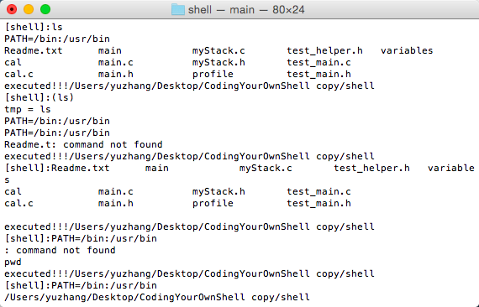

When we press control + c, it will promot “Are you sure?”. If “n” is chose, you can continue to type command lines. When “y” is chose, it will logout.

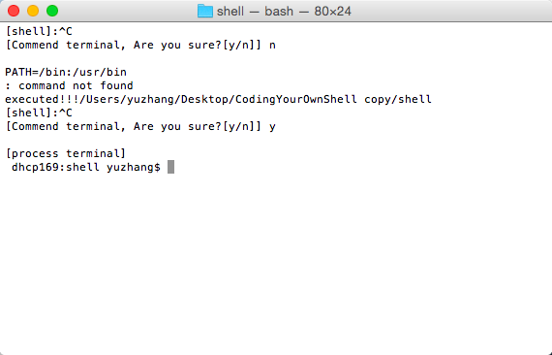

In order to realize the priority of command, we spent a lot of time discussing the structure of the data storage. We create several extra classes like “myStack.c” to implement some algorithms.